HTML And CSS

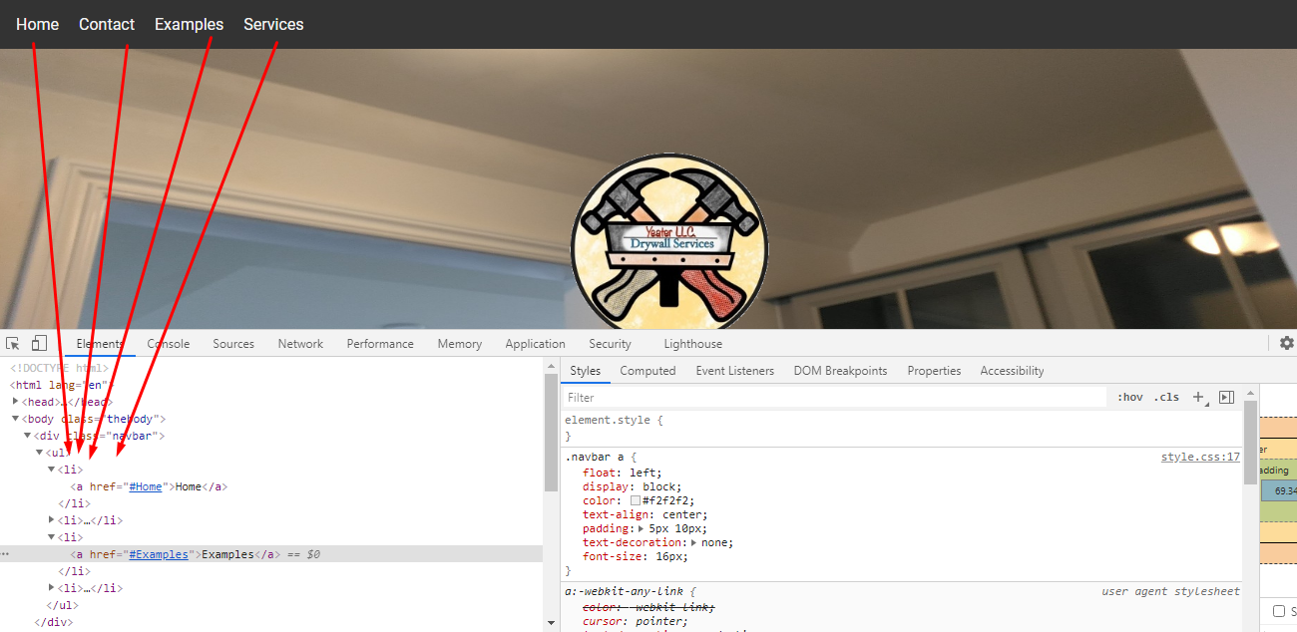

Add the ul li for menu .........>>>>>> like this

<ul>

<li><a href="#Home">Home</a></li>

<li> <a href="#ContactUs">Contact</a> </li>

<li><a href="#Examples">Examples</a></li>

<li> <a href="#Services">Services</a> </li>

</ul>

menu CSS

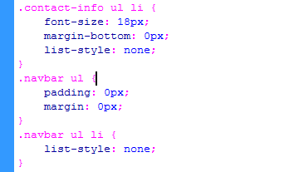

Add the html div

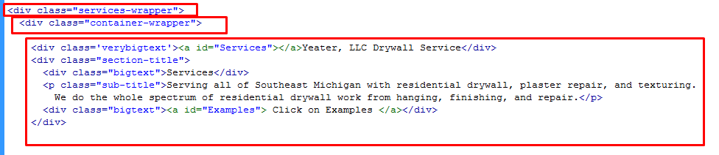

CSS

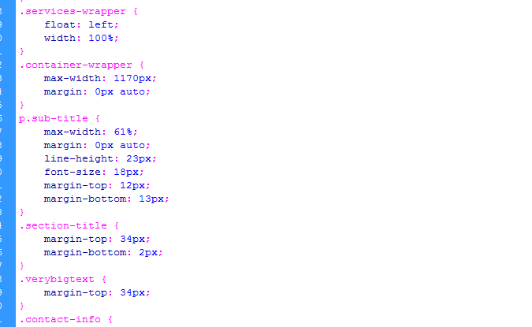

add the html code

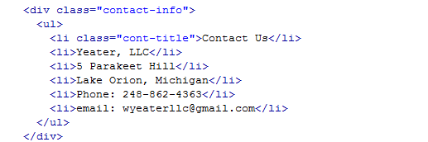

CSS

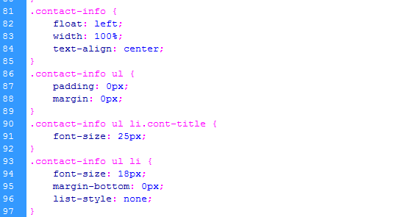

google font

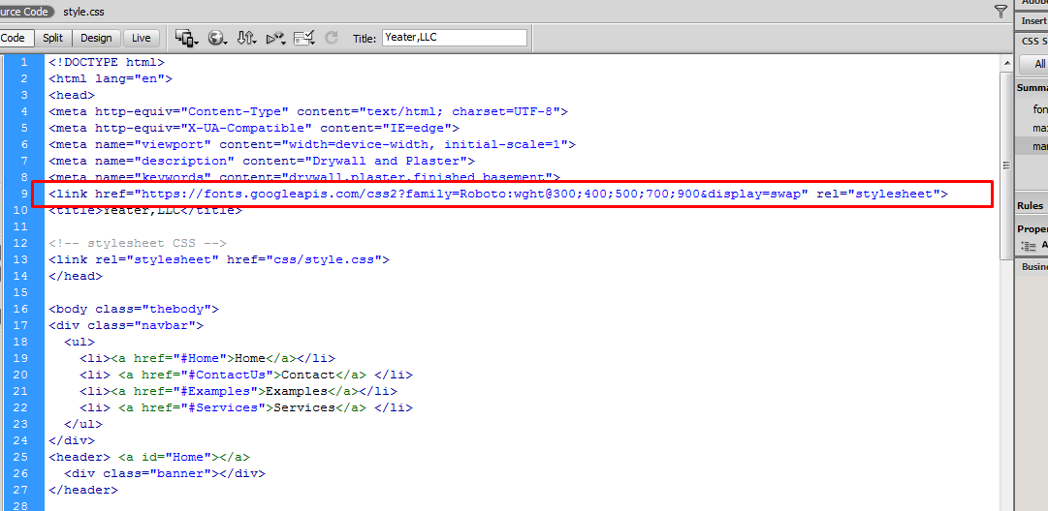

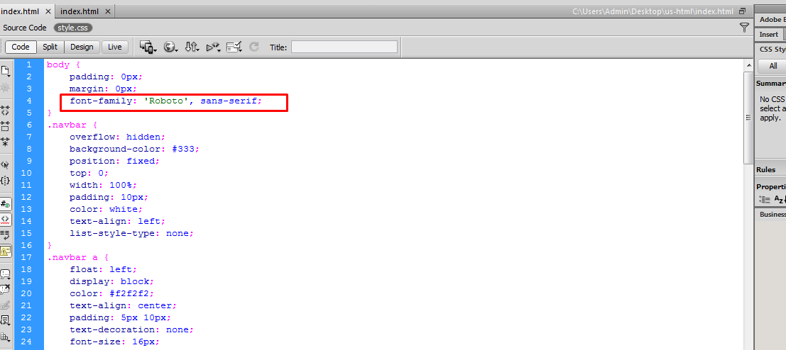

and use the media query for Mobile, Tablet

(1)

/\*\*\*\*\* Mobile Media query \*\*\*\*\*/

@media only screen and (max-width: 767px) {

}

(2)

/\*\*\*\*\* Tablet Media query \*\*\*\*\*/

@media all and (min-width: 768px) and (max-width: 1024px) {

}